Linear Search in 2-D Array

https://github.com/RPChinhara/LinearSearchIn2DArray.git

Rudrapratap Chinhara
B.Tech.Computer Science and Engineering
Roll. No. 202117
Central University of Haryana

Code:
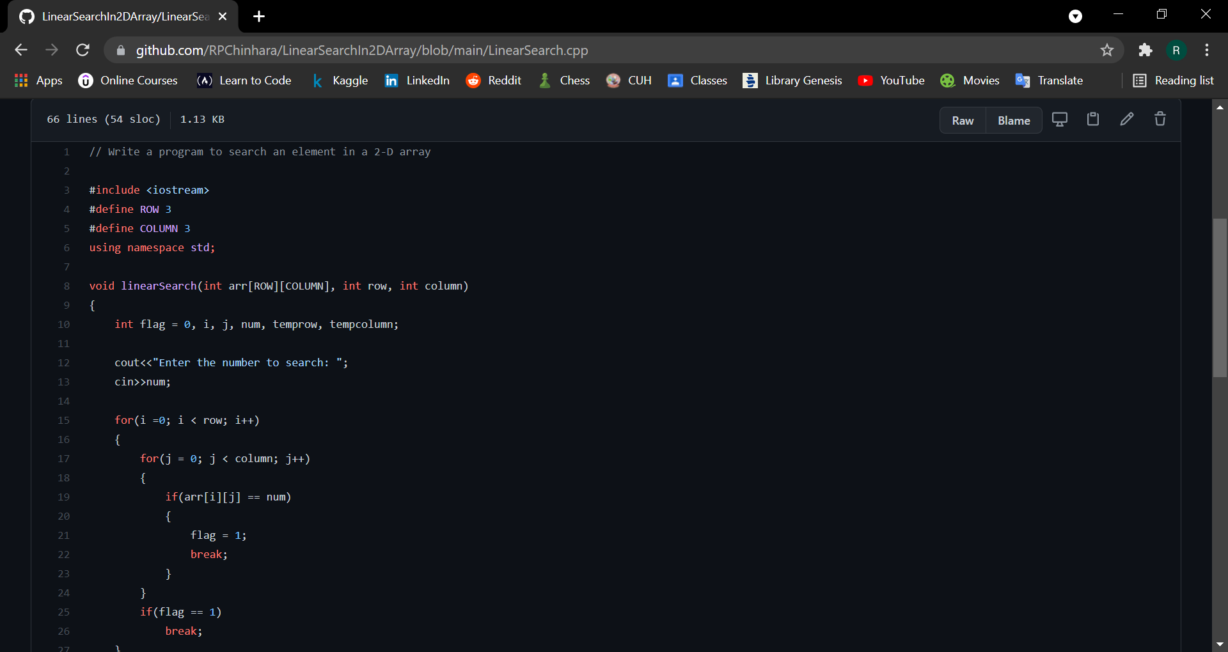

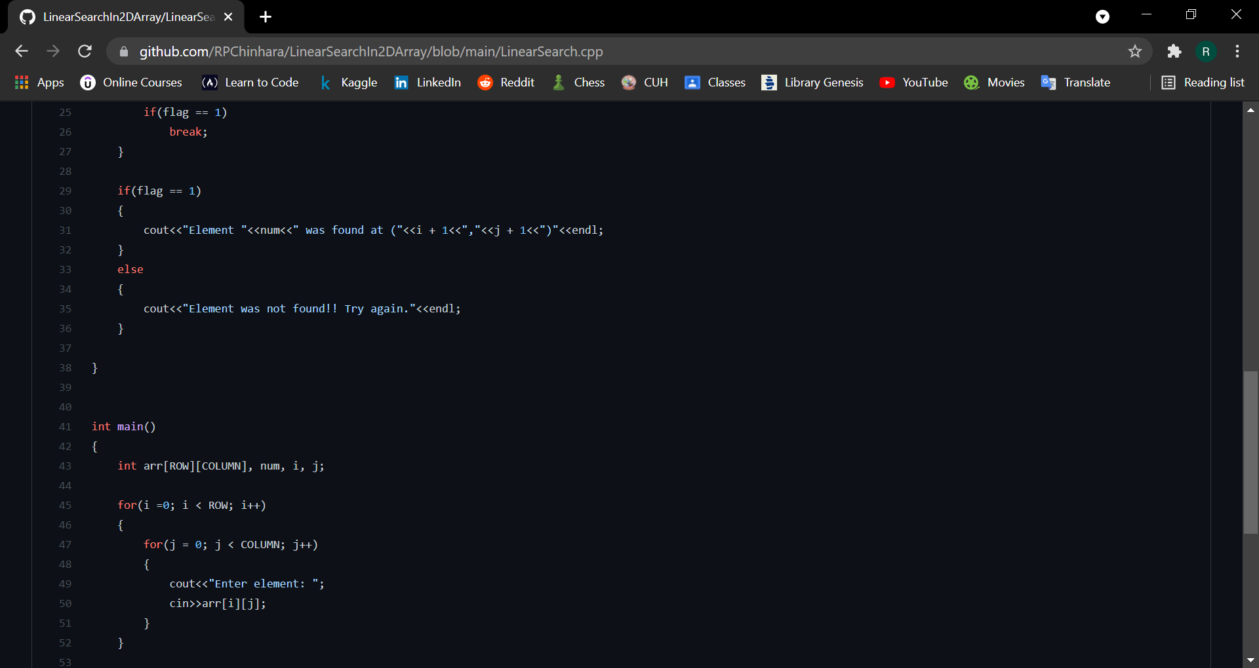
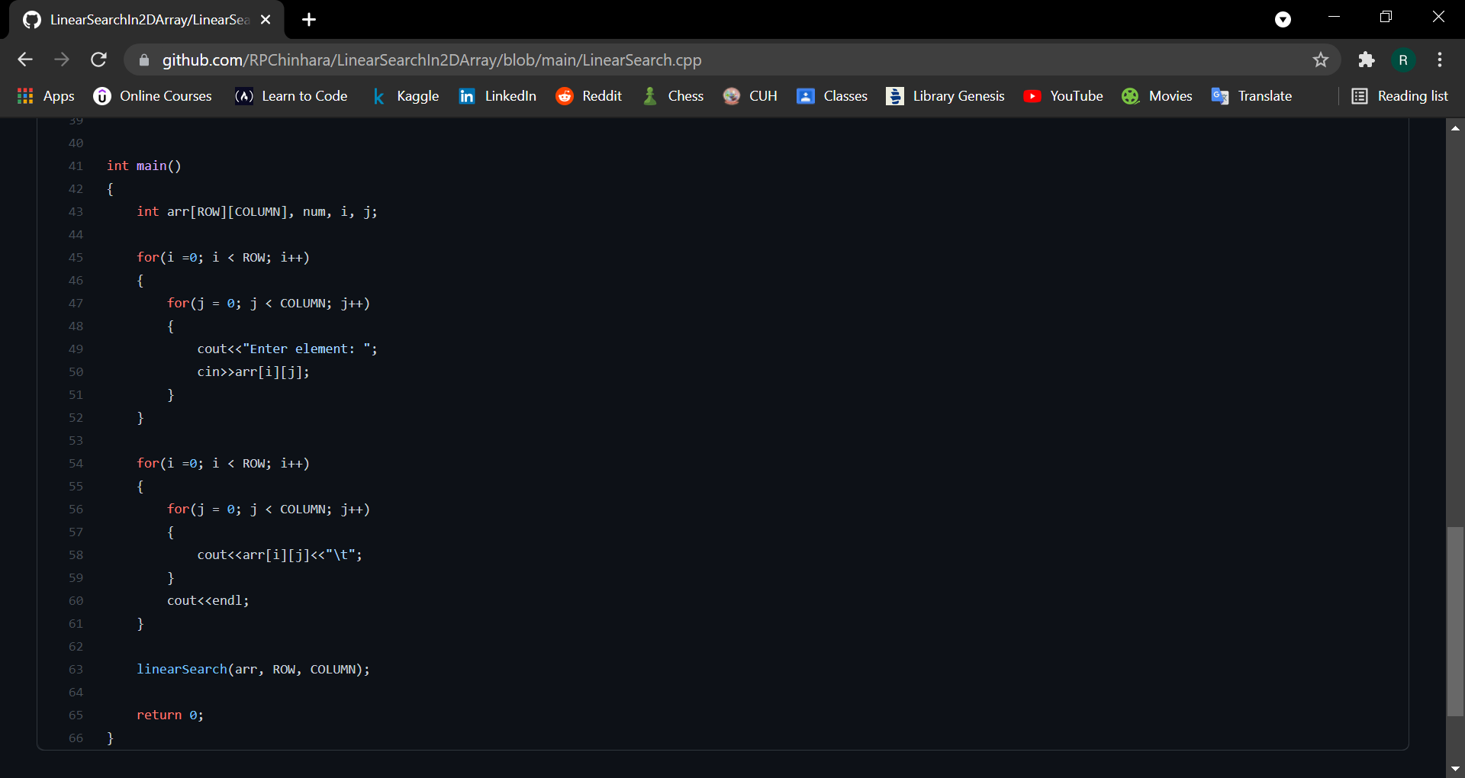

Output:
When the element is found in the array
